Final Strategic Plan for Netflix

Echo Liu, Applied Analytic Program in Columbia University

Part 1

## Introduction

Netflix is an online television network streaming TV shows and movies. According to Forbes 2018, Netflix is one of the largest multinational entertainment platforms with 130 million memberships in over 190 countries and it continues to expand globally. Netflix was found in 1997, and the firm is specialized in streaming media and video on demand, providing unlimited TV shows and movies, including original series, documentaries and feature films across a wide variety of genres. The company offers monthly subscriptions and free-trial memberships, and also as receive digital DVDs delivered to their homes. Netflix is a disruptive innovator in the media-service industry and it successful won over the biggest competitor in 2000s, Blockbuster. In this case study, we will analyze and generate a final strategic plan for Netflix using seven analytical tools: Mission and Vision, Porter’s Five Forces, SWOT Analysis, Issue Tree, Blue Ocean Strategy, Overall Roadmap, and Analytic Team Engagement.

## Mission Statement

From Netflix’s website, their core mission is to grow their streaming subscription business domestically and globally to increase consolidated net income. They are continuously improving the customer experience with a focus on expanding their streaming content, enhancing their customer experience and extending their streaming service to even more internet-connected devices.

## Vision Statement

“Becoming the best global entertainment distribution service.”

One of Netflix’s core value is its video streaming platform, with unlimited TV shows, movies, and original content. It encourages users to enjoy any content at any place, in any time and on any device, by doing this allows Netflix to also attract more potential users, while simultaneously giving its customer great value for their subscription.

## Porter’s Five Forces

Porter’s Five Forces model would allow Netflix to gain insight into the industry, identifying the magnitude of each of the five forces which affect the company’s business strategy and profitability.

**Threat of New Entrants: Moderate**

The barriers to entry to enter the streaming market are higher than other industries. Purchasing or producing content is highly expensive, only companies that already have sizable content libraries or large amounts of capital will be able to get into the business. In addition, the investment required to create a streaming platform and own the essential technologies is very capital intensive. This limits the number of entrants into the streaming industry to companies with a distribution platform or large library of original content. However, Netflix is facing an increasing number of competitors in the United States including HBO, CBS, Amazon, and Hulu. These companies to digital streaming market both have a competitive advantage in the amount of content that already own. While Netflix may face many new entrants within its sector, it remains unclear whether these firms are the true threat to Netflix.

**Bargaining Power of Suppliers. High**

As Netflix obtains the majority of its content through licensing with content proprietors, its suppliers have considerable bargaining power. Content licensing cost a insane price, Netflix spent 13.5 million dollars on each episode of The Walking Dead since 2014. In addition, potential suppliers are also offering their own digital streaming services. For example, Netflix has benefited from a licensing contract with Disney, however, Disney recently announced that they will not renew the agreement with Netflix since it is pursuing their own streaming platform starting this year.

**Bargaining Power of Buyers. High**

The current business model implemented by Netflix gives its users a large amount of bargaining power. Consumers face minimal consequences for cancelling subscriptions and switching to other streaming services. Additionally, the price sensitivity of Netflix consumers further increases their bargaining power, as Netflix raised its basic monthly subscription from $7.99 to $8.99, comparing to Disney Plus $6.99 per month, consumers are left with the choice which streaming service to subscribe to.

**Threat from Substitute Products. Moderate**

Each streaming platform offers an original and exclusive content that cannot be duplicated. Therefore, consumers are free to choose the streaming platforms based on the content they like the most provided by the service. Moreover, these streaming services cost relatively lower comparing to traditional home cables and DVDs, it is common for people to subscribe to several services based on their content desires. Thus, consumers do not feel the need to drop a streaming service to add another, minimizing the threat of substitutes.

**Competitive Rivalry. High**

Netflix faces highly competitive rivalry in the digital streaming business. As I said above, Netflix is competing against Disney, Hulu and Amazon directly - each one streams movies and TV shows and own their original content. Also, major networks like CBS and Fox are joining streaming video service game on their websites and apps for streaming devices like Apple TV and Google Chromecast. When users found that most of the shows they watch come from a single network, they might choose another streaming service over Netflix.

## SWOT Analysis

The goal of SWOT analysis is to match the company’s strengths to attractive opportunities in the environment while eliminating the weakness and minimizing the threats. Netflix's leadership in the industry, business model, brand recognition, and recommendation algorithm using user data gives it a competitive advantage as against the traditional digital service, whereas decreasing revenue and increasing debt remains an area of concern for the company. From the external aspect, intense competition and foreign exchange rate risk could affect the company’s profitability. However, international growth and technological improvement are likely to provide growth opportunities to Netflix.

|  |  |
| --- | --- |
| **Strength**  Industry Leader and Strong Business Model  Brand Recognition  Recommendation Algorithm/Consumer Data | **Weakness**  Lower revenue and Increasing debt |
| **Opportunity**    International Growth  Technological improvement | **Threat**  Intense competition  Foreign Exchange Rate Risk |

### Strength

Industry Leader and Strong Business Model

Netflix was the first company in the streaming market and is one of the world’s largest internet television networks with 130 millions memberships in over 190 countries. It is also currently the only pure-play (no advertisement) digital streaming company that is publicly traded in the US.

Netflix’s business model is to provides different levels of monthly memberships with unlimited video streaming, and DVDs in the most convenient way as they are delivered to users’ addresses and subscribers can return these DVDs through pre-paid postage envelopes. The company also provides a free-trial period as a promotional offer to attract new customers. This innovative business model that Netflix operates gives it a clear competitive advantage.

Brand Recognition

Since Launching its streaming service, Netflix has become a pop-culture phenomenon. The company holds many hot original content including House of Cards, Stranger Things, Orange is the New Black, Black Mirror and more. Netflix has built a strong following through social media and word-of-mouth which enhances the brand recognition. Nowadays, “Netflix and Chill” becomes a public phrase as the way to express the feeling of relaxation and freedom, lazy Weekends, and nights after a long day at work.

Recommendation Algorithm/Consumer Data

Netflix has the access to collect vast amounts of user data including personal information, preferences, duration of video watching and more. The firm then create a recommendation algorithm to make their content library more user-friendly and accessible to subscribers, which increase the customer satisfaction and stickiness. Because of this recommendation system, Netflix’s user experience is noticeably smoother than other services. From all that data, Netflix knows exactly what shows are being watched, by who, when, where and for how long. This consumer data is impayable when deciding what type of content to add to its library to attract users.

### Weakness

Lower revenue and Increasing debt

Since Netflix refuses to provide advertisement for users and its revenue only depends on subscriptions, the firm faces a potential problem with decreasing revenue and increasing debt. This could also concern the investors and make it difficult to raise funds on the market. Creating original content is highly expensive, and domestic growth has slowed recently. These factors increase the pressure on firm’s debt, affects its cash flow and decrease the overall revenue, also it would increase the company’s vulnerability to adverse economic and industry conditions.

### Opportunity

International Growth

Netflix has a huge opportunity to become a leading video streaming platform globally, as they have already taken steps toward this goal with over 190 countries involvement. By following foreign regulations, providing foreign language translation, and creating local original content tailoring with foreign tastes, they are approaching their goal becoming the world’s standard streaming service.

Technological Improvement

Netflix relies on technology to survive in the streaming market. From Statista, the percentage of mobile phone users in global population in 2019 is 67.1% and the number is increasing year by year. It provides a potential opportunity to develop Netflix’s technology on mobile phones to increase users. Since mobile data connection is becoming faster and more reliable, Netflix has a chance to expand as technology offers more ways for subscribers to consumer content.

### Threat

Intense competition

The company operates in an industry that is changing rapidly and intensely competitive. Netflix faces competition from other entertainment video providers, including multichannel video programming distributors, internet-based content providers, video gaming providers and DVD retailers. It competes against other sources of entertainment that its members could choose in their moments of free time. As mentioned above, it also competes against entertainment video providers and content producers such as Amazon, Hulu and Disney. Such intense competition could result in competitive pricing and in turn pressurize the margins of the company.

Foreign Exchange Rates Risk

With an international business growing at fluctuating rates, Netflix will be exposed to increasing level of currency risks.

## Identification of Opportunity or Problem to Address

### **Blue Ocean Strategy**

I have chosen Amazon Prime Video and Hulu as comparison with Netflix business model. The Strategy canvas visualizes the factors that three firms compete on and what customers receive from the existing competitive offerings in the industry. The horizontal axis indicates the range of factors the industry competes on, and the vertical axis captures the offering level that customers receive across all these key factors.

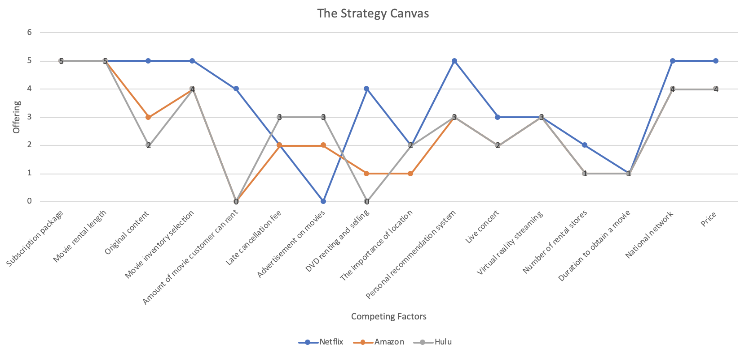

The graph indicates that Netflix is leaving Blue Oceans since an increasing number competitors are entering the digital streaming industry. Service and product differentiation is critical for the firm to recreate a new Blue Ocean.

ERRC helps the firm to proceed with pursuing differentiation and cost reduction at the same time. According to the ERRC four-actions framework, the elements that Netflix have to implement in order to eliminate, raise, reduce and create different factors to beat the competitors are as follows:

|  |  |
| --- | --- |
| **Eliminate**  Advertisement of movies  Late cancellation fee  DVDs selling and renting  Number of rental stores | **Raise**  Subscriptions  Original content  Movie rental length  Amounts of movies customer can rent  Movie inventory selection  National network |
| **Reduce**  Duration to obtain a movie  The importance of location  Price per movie rented  Subscription options | **Create**  Personal recommendation system  Database of subscribers  Live concert  Virtual reality streaming |

### Issue Tree

The Issue Tree analysis is a valuable tool to disaggregate an issue into core sub-issues that need to be addressed to answer the main question. In order to identify strategic opportunities in a systematic way for Netflix, the Issue Tree analysis was conducted and demonstrated below: 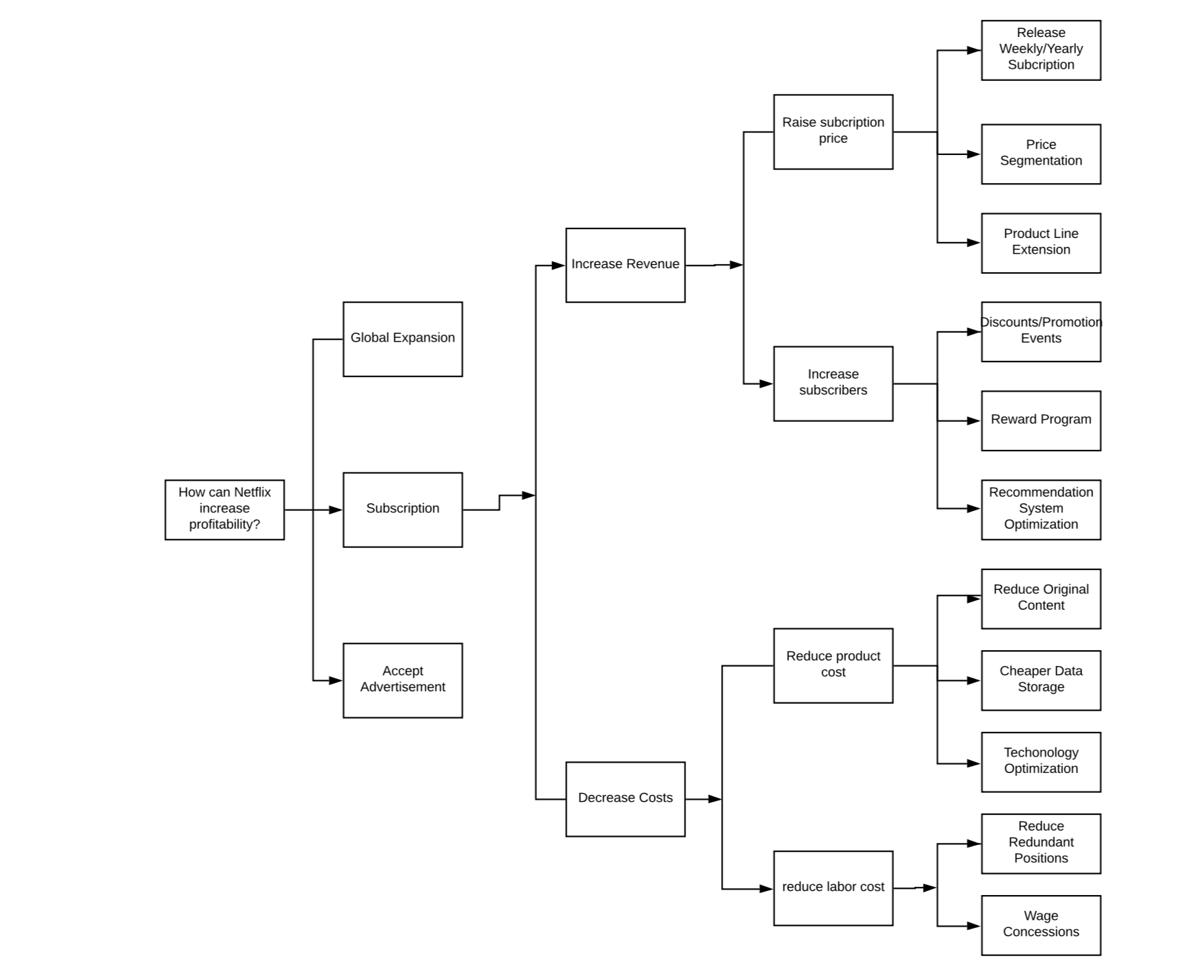

As shown in the Issue Tree, if Netflix plans to increase its overall revenue, the company should seek opportunities to expand globally, explore more on subscription, and accept advertisement. If we look further in subscription, the ways to increase the revenue are raising subscription price and increasing the number of subscribers. Besides monthly subscription, Netflix could release weekly/yearly subscription plans to add more flexibility for users, yet raising price on weekly and monthly payment and providing discount for yearly subscribers. In addition, Netflix can segment the content for different price range. For instance, we need to be the premium subscribers to watch Netflix Original Content like *House of Cards*. Furthermore, Netflix can extend the product lines such as virtual reality streaming and live concert. The ways of increasing the number of subscribers are providing discounts/promotion events, creating reward program and optimizing recommendation system. Since Netflix generates rich user data, tracking users’ watching duration, preference and their email address are easy, the firm could take advantage of rich data using some methods above to attract more consumers. As for cost deduction, Netflix could reduce product cost by reducing original content, seeking for cheaper data storage and optimizing technology. Additionally, the firm could cut some redundant positions and negotiate about compensations to reduce labor cost.

From the Issue Tree framework, we identified that the most appropriate strategy for Netflix would be launch weekly/yearly subscription plans to add more flexibility and enhance user loyalty while increasing the net price of subscription, and launch new product lines including live concerts and VR streaming to enhance its brand recognition and ultimately increase Netflix’s profitability.

## Strategic Options Considered

**Multi Side Platform**

Multi Side Platform are platforms that connect two or more groups of people and enable interactions between them. According to Andrei’s article in Harvard Business Review,

it seems obvious that Netflix can and should become a MSP. Netflix’s huge consumer base (130 million worldwide) and content-delivery infrastructure are very appealing to many third parties. In addition to video content providers, these third parties include marketers and the developers of cloud gaming or other services. The way that Netflix become a platform is simply by allowing these third parties to sell their products or services within Netflix’s service but outside Netflix’s subscription, on terms controlled by the third parties.

Becoming a MSP in this way would allow Netflix to utilize a different dimension of growth: selling more stuff to the same consumers. And the another advantage of the MSP model is that Netflix can grow without having to buy or produce the new content itself. It just has to attract third parties to develop and sell the content, and then it can cost a share of the revenue or a transaction fee. Moreover, third parties could attempt new forms of content, which could be valuable to Netflix’s content acquisition and production efforts.

**Selected Strategy & Implementation Plan: Two-year Roadmap**

As indicated in prior strategic analysis, the selected strategy for Netflix is to keep its existing business model, and at the same time launch weekly/yearly subscription plans and new product lines such as VR streaming and live concerts to diversify its business model and ultimately increase Netflix’s profitability. Users have more flexibilities when choosing subscription plans while Netflix still offers no cancellation fees and cancel anytime policy. Additionally, subscribers have a chance to enjoy their favorite live concerts without ridiculous ticket prices and overcrowded halls, while enjoying the music at home, laying on the couch, eating their favorite snacks.

To deploy this strategy, I have concluded a two-year roadmap for Netflix as follows:

|  |  |  |
| --- | --- | --- |
|  | **Year 1** | **Year 2** |
| **Subscription Plan** | Introducing weekly/year subscription plan | Providing discounts and reward program for existing subscribers |
| **Global Expansion** | Introducing foreign language options on the screen | Creating local original content for certain countries |
| **New Product Lines** | Introducing VR streaming and live concerts | Providing live videogames and kids games |

As demonstrated above, Netflix could expand its business through creating more subscription plan, expanding globally and introducing new product lines in two years and increase the firm’s overall revenue.

Part 2

## Analytics Engagement

Analytics team in Netflix is crucial. One of the firm’s competitive advantage is recommendation system, that the analytic team analyzes all the user data including their personal information, preferences and more, to make their content library more user-friendly and accessible to subscribers, which increase the consumer satisfaction and stickiness. Data analytics allows Netflix to make its foray into deep personalization of user experience.

Business analytics is necessary when it is utilized to help the firm understanding its business market and making timely and effective business adjustments. In order to adjust subscription plan and carry out advertisement, the firm needs to have a deep understanding of its consumers. Working with the analytics team, Netflix will be able to visualize their customers and identify profitable or underperforming segments by figuring out subscribers’ watching habits, interests, and preferences. Netflix should strike to roll out a strong, integrated customer relationship management effort that is tightly integrated with its analytic findings. By tailoring watching experience to individual user, Netflix will be able to further ingrain the company in video streaming market and ultimately increase profitability.

## Reference

Netflix Inc. <https://netflixcompanyprofile.weebly.com/>

Hagiu, A. (2018, August 14). *The Best Way for Netflix to Keep Growing*. Harvard Business

Review. Retrieved from:

<https://hbr.org/2018/08/the-best-way-for-netflix-to-keep-growing>

Christian, R. & Spooner, W.(2017, November 10). *Krause Fund Research Fall 2017.*

Retrieved from:

<https://tippie.uiowa.edu/sites/tippie.uiowa.edu/files/documents/krause/f17_nflx.pdf>

Porter’s Analysis of Netflix. Retrieved from

<https://www.porteranalysis.com/porters-five-forces-of-netflix/>